Department of Computer Science and Engineering
Lab Report
Lab Report No | : | 02
Lab Report Name | :
Course Title | : | Computer Algorithm and Complexity Sessional
Course Code | : | CSE 222
Name | : | Jannatul Mawa
ID | : | 1119015
Level | : | 2 | Term | : | 2 | Section | : | A | Group | : | G2
Date of Submission | : | 29/04/2026 | Semester | : | Spring | Year | : | 2026

Marking Rubric
Problem Understanding & Report Clarity (3) | Implementation (4) | Results, Analysis & Presentation (3) | Total(10)

Key Learning:
- To understand and implement Insertion Sort for ascending order.
- To learn Bubble Sort for descending order sorting.
- To apply Selection Sort for arranging data in ascending order.
- To compare different sorting techniques and their behavior.

Code 1 Input & Output:
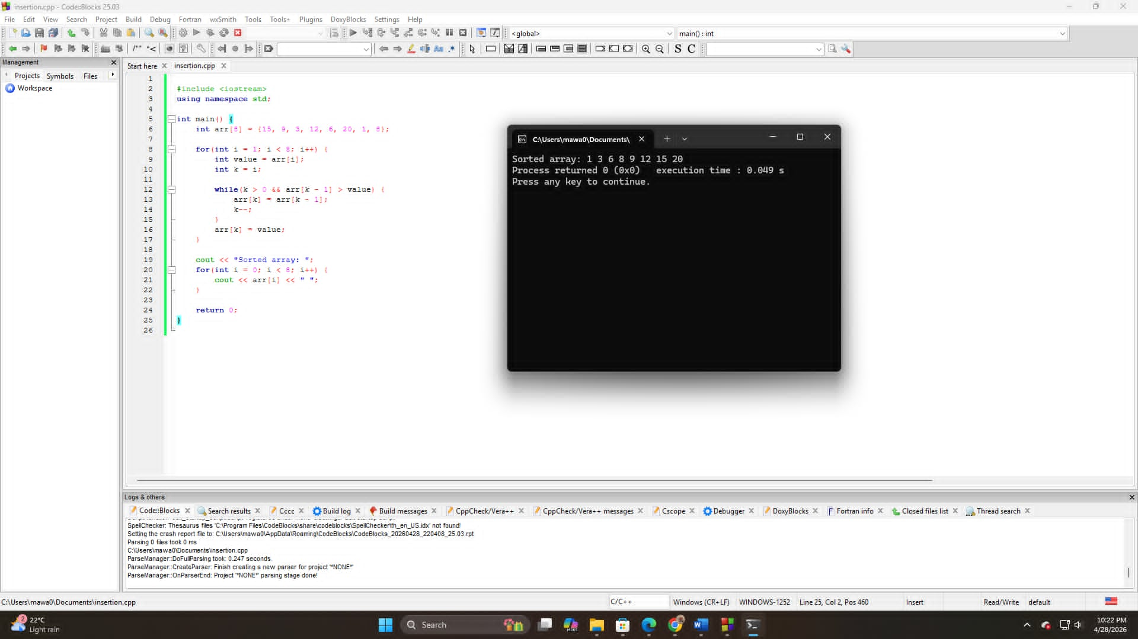

Code 2 Input & Output:
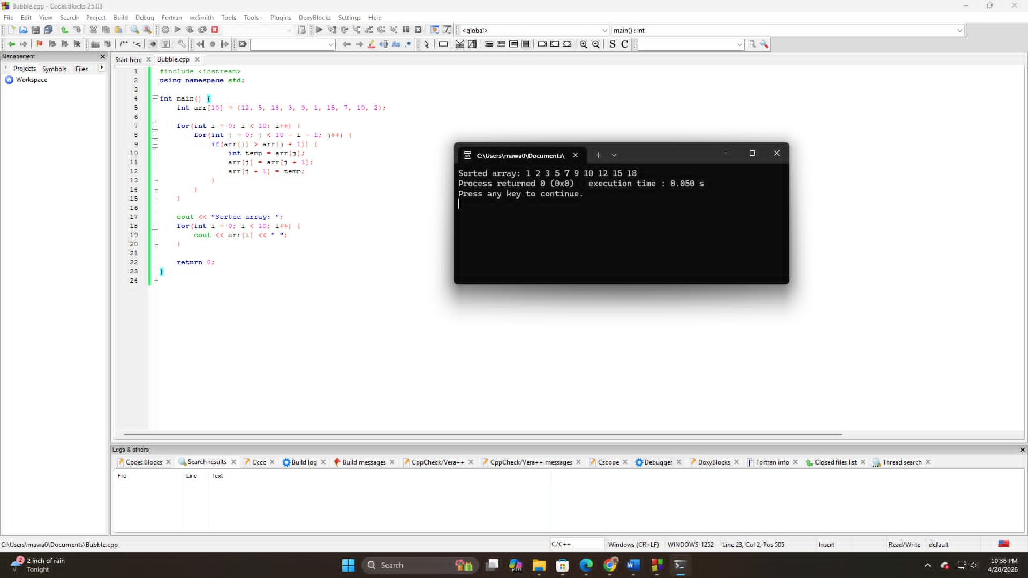

Code 3 Input & Output:

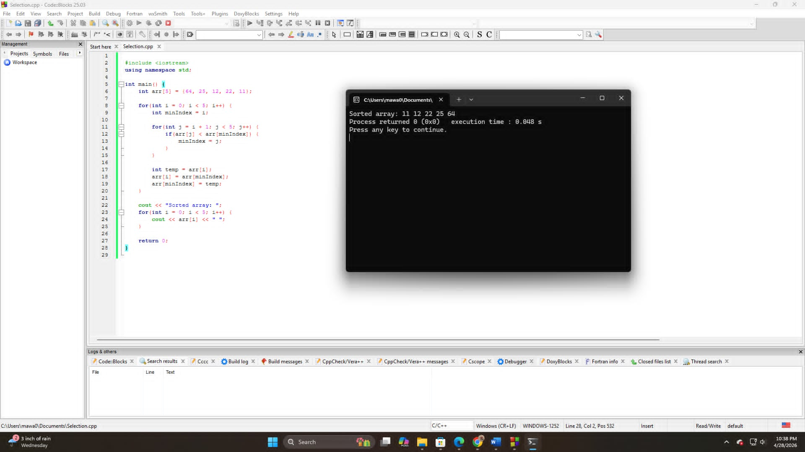

Conclusion:
In this lab experiment, we successfully implemented three different sorting algorithms: Insertion Sort, Bubble Sort, and Selection Sort. Each algorithm was used to sort data in either ascending or descending order. Through this experiment, we learned how different sorting techniques work step by step and how they can be applied to real-life data such as exam scores and product prices. This improves understanding of algorithm efficiency and problem-solving skills in programming.

